**Configuring SSL on Tomcat Server**

1. Set the JAVA_HOME path:

export JAVA_HOME="/home/tomcat/Downloads/java/jdk-11.0.21"

export PATH=$JAVA_HOME/bin:$PATH

1. Generate Keystore:

keytool -genkey -keystore /home/tomcat/Downloads/tomcat/demokey.jks -keyalg RSA -keysize 2048 -storepass password -validity 365

1. Goto Conf directory path:

/home/tomcat/Downloads/tomcat/apache-tomcat-9.0.85/conf

1. Edit the server.xml conf file and update the jks path and password as mentioned below:





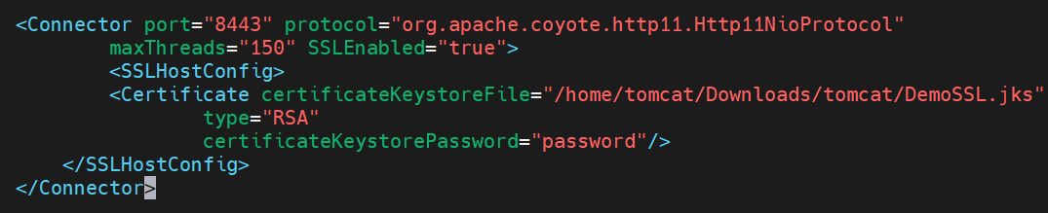

1. Restart the Tomcat Server to reflect changes.

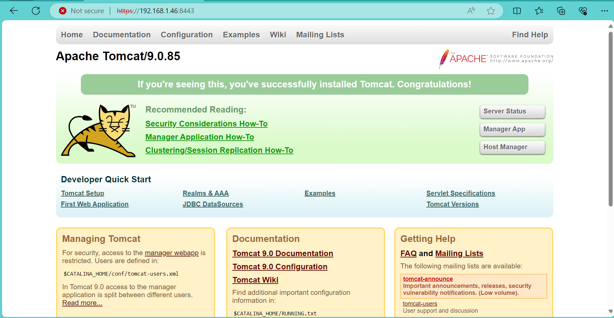

1. Generate CSR Certificate from JKS file:

keytool -export -keystore DemoSSL.jks -storepass password -file /home/tomcat/Downloads/tomcat/DemoSSL.cer -keypass password



1. Generate Trust from CSR file:

keytool -import -file DemoSSL.cer -keystore /home/tomcat/Downloads/tomcat/DemoTrust.jks -keypass password

